Many different Native American groups lived on the East Coast of what would become United States. They spoke many different languages. Some were farmers, some were hunters. Some fought many wars, others were peaceful. These groups are called tribes. These tribes had developed their own cultures many years before the first European settlers arrived. Each had a kind of religion, a strong spiritual belief. Many tribes shared a similar one.
The Indians on the East Coast shared a highly developed system of trade. Researchers say different tribes of Native Americans traded goods all across the country. The first recorded meetings between Europeans and the natives of the East Coast took place in the 1500s. Fishermen from France and the Basque area of Spain crossed the Atlantic Ocean. They searched for whales along the east coast of North America. They made temporary camps along the coast. They often traded with the local Indians. The Europeans often paid Indians to work for them. Both groups found this to be a successful relationship. Several times different groups of fishermen tried to establish a permanent settlement on the coast, but the severe winters made it impossible. These fishing camps were only temporary.
The first permanent settlers in New England began arriving in 1620. They wanted to live in peace with the Indians. They needed to trade with them for food. The settlers also knew that a battle would result in their own, quick defeat because they were so few in number. Yet, problems began almost immediately. Perhaps the most serious was the different way the American Indians and the Europeans thought about land. This difference created problems that would not be solved during the next several hundred years.
Land was extremely important to the European settlers. In England, and most other countries, land meant wealth. Owning large amounts of land meant a person had great wealth and political power. Many of the settlers in this new country could never have owned land in Europe. They were too poor. And they belonged to minority religious groups. When they arrived in the new country, they discovered no one seemed to own the huge amounts of land. Companies in England needed to find people willing to settle in the new country. So they offered land to anyone who would take the chance of crossing the Atlantic Ocean. For many, it was a dream come true. It was a way to improve their lives. The land gave them a chance to become wealthy and powerful.
American Indians believed no person could own land. They believed, however, that anyone could use it. Anyone who wanted to live on and grow crops on a piece of land was able to do so. The American Indians lived within nature. They were able to do this because they understood the land and their environment. They did not try to change the land. They might farm in an area for a few years. Then they would move on. They permitted the land on which they had farmed to become wild again. They might hunt on one area of land for some time, but again they would move on. They hunted only what they could eat, so the numbers of animals continued to increase. The Indians understood nature and made it work for them.
The first Europeans to settle in New England in the northeastern part of America were few in number. They wanted land. The Indians did not fear them. There was enough land for everyone to use and plant crops. It was easy to live together. The Indians helped the settlers by teaching them how to plant crops and survive on the land. But the Indians did not understand that the settlers were going to keep the land. This idea was foreign to the Indians. It was like to trying to own the air, or the clouds.
As the years passed, more and more settlers arrived, and took more and more land. They cut down trees. They built fences to keep people and animals out. They demanded that the Indians stay off their land.
Religion was another problem between the settlers and the Indians. The settlers in New England were very serious about their Christian religion. They thought it was the one true faith and all people should believe in it. They soon learned that the Indians were not interested in learning about it or changing their beliefs. Many settlers came to believe that Native Americans could not be trusted because they were not Christians. The settler groups began to fear the Indians. They thought of the Indians as a people who were evil because they had no religion. The settlers told the Indians they must change and become Christians. The Indians did not understand why they should change anything. The European settlers failed to understand that the Native American Indians were extremely religious people with a strong belief in unseen powers. The Indians lived very close to nature. They believed that all things in the universe depend on each other. All native tribes had ceremonies that honored a creator of nature. American Indians recognized the work of the creator of the world in their everyday life.
Other events also led to serious problems between the Native Americans and the settlers. One serious problem was disease. The settlers brought sickness with them from Europe. For example, the disease smallpox was well known in Europe. Some people carried the bacteria that caused smallpox, although they did not suffer the sickness itself. Smallpox was unknown to Native Americans. Their bodies' defense systems could not fight against smallpox. It killed whole tribes. And, smallpox was only one such disease. There were many others.
The first meetings between settlers and Native Americans were the same in almost every European settlement on the East Coast of America. The two groups met as friends. They would begin by trading for food and other goods. In time, however, something would happen to cause a crisis. Perhaps a settler would demand that an Indian stay off the settler's land. Perhaps a settler, or Indian, was killed. Fear would replace friendship. One side or the other would answer what they believed was an attack. A good example of this is the violent clash called King Philip's War.
Matacom was a leader of the Wampanoag tribe that lived in the northern-most colonies. He was known to the English as King Philip. Without the help of his tribe, the first European settlers in that area might not have survived their first winter. The Wampanoag Indians provided them with food. They taught the settlers how to plant corn and other food crops. The two groups were very friendly for several years. As the years passed, however, fear and a lack of understanding increased. Matacom's brother died of a European disease. Matacom blamed the settlers. He also saw how the increasing numbers of settlers were changing the land. He believed they were destroying it.
One small crisis after another led to the killing of a Christian Indian who lived with the settlers. The settlers answered this by killing three Indians. A war quickly followed. It began in 1675 and continued for almost two years. It was an extremely cruel war. Men, women and children on both sides were killed. Researchers believe more than six hundred settlers were killed. They also say as many as three thousand Native Americans died in the violence.History experts say the tribe of Indians called the Narraganset were the true victims of King Philip's War. The Narraganset were not involved in the war. They did not support one group or the other. However, the settlers killed almost all the Narraganset Indians because they had learned to fear all Indians.

The 13 American Colonies-Coming to America
The first colonies in North America were along the eastern coast. Settlers from Spain, France, Sweden, Holland, and England claimed land beginning in the 17th century. The struggle for control of this land would continue for more than a hundred years.
The first permanent settlement in North America was the English colony at Jamestown, in 1607, in what is now Virginia. John Smith and company had come to stay. The Pilgrims followed, in 1620, and set up a colony at Plymouth, in what is now Massachusetts.
Other English colonies sprang up all along the Atlantic coast, from Maine in the north to Georgia in the south. Swedish and Dutch colonies took shape in and around what is now New York. As more and more people arrived in the New World, more and more disputes arose over territory. Many wars were fought in the 1600s and 1700s. Soon, the two countries with the largest presence were England and France.
The two nations fought for control of North America in what Americans call the French and Indian War (1754-1763). England won the war and got control of Canada, as well as keeping control of all the English colonies. By this time, the English colonies numbered 13. They were Massachusetts, New Hampshire, Connecticut, Rhode Island, New York, New Jersey, Pennsylvania, Maryland, Delaware, Virginia, North Carolina, South Carolina, and Georgia.
Part 2: Characteristics of the Colonies
Each colony had its own unique characteristics, but historians lump them into groups based on where they were, why they were founded, and what kinds of industry they had:
New England Colonies  Rhode Island  Connecticut  Massachusetts  New Hampshire | Middle Colonies  Delaware  Pennsylvania  New York  New Jersey | Southern Colonies  Maryland  Virginia  North Carolina  South Carolina  Georgia
Motivations
By and large, the people who settled in the New England Colonies wanted to keep their family unit together and practice their own religion. They were used to doing many things themselves and not depending on other people for much. Some of these people came to New England to make money, but they were not the majority.
The people who founded the Middle Colonies were looking to practice their own religion (Pennsylvania mainly) or to make money. Many of these people didn't bring their families with them from England and were the perfect workers for the hard work required in ironworks and shipyards.
The founders of the Southern Colonies were, for the most part, out to make money. They brought their families, as did the New England colonists, and they kept their families together on the plantations. But their main motivation was to make the good money that was available in the new American market.
Economy
The New England Colonies were largely farming and fishing communities. The people made their own clothes and shoes. They grew much of their own food. Crops like corn and wheat grew in large numbers, and much was shipped to England. Foods that didn't grow in America were shipped from England. Boston was the major New England port.
The Middle Colonies were part agriculture, part industrial. Wheat and other grains grew on farms in Pennsylvania and New York. Factories in Maryland produced iron, and factories in Pennsylvania produced paper and textiles. Trade with England was plentiful in these colonies as well.
The Southern Colonies were almost entirely agricultural. The main feature was the plantation, a large plot of land that contained a great many acres of farmland and buildings in which lived the people who owned the land and the people who worked the land. (A large part of the workforce was African slaves, who first arrived in 1619.) Southern plantations grew tobacco, rice, and indigo, which they sold to buyers in England and elsewhere in America.
Part 3: Beliefs and Revolution
Beliefs
The Pilgrims in Massachusetts and the Quakers in Pennsylvania were examples of people who had left England so they could practice the religion they chose. Maryland and Rhode Island passed laws of religious toleration (meaning that people couldn't be harmed just because their religion was different from other people's).
These American colonists also believed that they had a right to govern themselves. More and more, they believed that they shouldn't have to pay so much in taxes to England, especially since they couldn't serve in the English government and have a say on how high or low those taxes were.
Revolution
As more and more Americans voiced their concerns over higher and higher taxes, a conflict began to build. The English response was to isolate the colonies from each other, in hopes that the American people would not pull together as a whole. An example of this is the Intolerable Acts, which singled out Massachusetts in general and Boston in particular. One provision of these Acts was to close the port of Boston entirely. This was serious business. Boston was one of the largest ports in America. Closing it meant that Americans couldn't get food and other essentials from England or anywhere else, unless they paid extra for it to be transported from other ports, like New York.
But the punishment of Boston backfired. The Americans pulled together as never before. They took up arms against their English governors and fellow soldiers. Even though they had fought for England in the French and Indian War (George Washington included), they now fought against England for the right to govern themselves. The result was the Revolutionary War, which ended in American victory. A new nation was born, one that had its roots in the conflicts between several European nations. That new nation would have to make its own way in an angry world.

Surviving Early American Colonial Life - Starving Colonists and Hostile Indians
Daily American Colonial Life was extremely harsh for the first settlers and colonists. They were faced with a new country, unknown territory and no friends, relatives or neighbors to help them. Some of the Native American Indians, like the Powhatan Native Indians, saved the lives of the first colonists and pioneers such as Captain John Smith. John Smith was captured by Chief Powhatan but was saved by his daughter, Pocahontas which led to the colonists receiving help from the Native Americans. The Powhatan became unhappy with the colonists encroaching on their homelands and stopped trading with them in an attempt to starve them out and the First Powhatan War erupted. The first colonists endured a terrible period between 1609-1610 that would become known as the 'Starving Time'. The Powhatan Wars continued until the defeat of the Powhatan Confederacy in 1646. The very survival of the first colonists of Virginia was due to the rule of Thomas Dale and Good Order in which he organized the colonists to work, ensuring that crops were planted and seeds sown. Wars with the Native American Indians continued throughout the period of Colonialism - American colonial life was harsh indeed requiring determination and strong work ethics to succeed in American Colonial Life.
Early American Colonial Life - The Great Migration
The Puritans had strong work ethics and were determined to overcome all odds to achieve their quest for religious freedom in North America and sailed 3000 miles on the Mayflower Ship and established the Plymouth Settlement. In the spring of 1630, John Winthrop led a fleet of 11 vessels and 700 passengers to the Massachusetts Bay Colony and other colonists and settlers followed. Between 1620 and 1640 twenty thousand English men, women, and children crossed the Atlantic Ocean to settle New England in the Great Migration. The lands occupied by the new Americans expanded and 13 colonies were established. By 1775 there were 2.5 million people who had travelled to North America to enjoy the colonial life.
American Colonial Life in the 3 Regions and 13 Colonies
There were 3 main regions in Colonial America. They were the New England colonies, the Middle colonies and the Southern colonies. American Colonial life varied between the three regions and their lifestyles were based on:
- Colonial Life dictated by Climate: The hottest colonies were in the South
- Colonial Life dictated by Geography: Rivers and waterways, mountains, soil
- Colonial Life dictated by Natural Resources: Timber, iron, copper, fish, whales, coal, furs - Refer to Colonial Food
- Colonial Life dictated by Industries: Dictated by natural resources
- Colonial Life dictated by Government: Charter Colonies, Royal Colonies or Proprietary Colonies
- Colonial Life dictated by Religion: Regions and colonies were at first dominated by a specific religion such as the Puritans
- Colonial Life dictated by Wealth in Colonial Society: Status dictated lifestyles including the clothing and dress of colonists, their food, their education and their occupations
Daily American Colonial Life in the late 1700's
 | Daily Colonial Life Fact 1 | Colonial Education: The education of girls was practically non-existent - they were taught household skills related to running the house or farm and raising the children. Wealthy boys were tutored at home. Other boys attended a Dame School up to the age of five then went on the Elementary or Grammar schools until they were 14 years old. Wealthy boys were sent to colleges or universities.
 | Daily Colonial Life Fact 2 | Colonial Women: The lives of women were dictated by their status. Wealthy women had servants and slaves and directed the work.
 | Daily Colonial Life Fact 3 | Rights: Women could not vote. Men of the wealthy upper class could vote and hold public office. Men of the middle class could also vote but few held public office. Men of the lower classes could not vote and most were illiterate. Indentured servants and slaves did not have the right to vote.
 | Daily Colonial Life Fact 4 | Marriage: Women were be married by the time they were 20 years old. Men married at a similar age. Widows and widowers married quickly, usually within a year.
 | Daily Colonial Life Fact 5 | Divorce: Divorce was practically unknown as Colonial America was essentially a divorce-free society
 | Daily Colonial Life Fact 6 | Children: Women bore large numbers of children. Eight children was normal but as the child mortality rate was extremely high up to five of the children would have died before they reached maturity.
 | Daily Colonial Life Fact 7 | Colonial Clothing: The types of clothes worn by colonists depended on wealth and religion. The upper classes wore fine materials, dress and ornaments. Puritans wore the simplest types of clothing. Poor people wore cheap 'homespun' garments
 | Daily Colonial Life Fact 8 | Medicine: Most doctors and physicians were poorly trained and not highly esteemed. When a physician was not available, a barber was often called to tend the sick
 | Daily Colonial Life Fact 9 | Diseases: There were no cures for deadly diseases such as typhoid, cholera, yellow fever, smallpox, measles, whooping cough and influenza.
 | Daily Colonial Life Fact 10 | Cures for Diseases - Powdered dried toad was used to treat smallpox which afflicted one out of five people in the great epidemics
 | Daily Colonial Life Fact 11 | Colonial Houses: The type of houses ranged from log cabins, farmhouses, town houses to great colonial mansions.
 | Daily Colonial Life Fact 12 | Colonial Society: Male dominated society where women were subservient to the men
 | Daily Colonial Life Fact 13 | Rights: Women could not vote. Men of the wealthy upper class could vote and hold public office. Men of the middle class could also vote but few held public office. Men of the lower classes could not vote and most were illiterate. Indentured servants and slaves did not have the right to vote.
 | Daily Colonial Life Fact 14 | Indentured Servants: Indentured Servants were not paid any wages for the term of the contract (5 - 7 years), they could not vote, buy or sell anything, they were not allowed to marry or to leave their houses or travel without permission
 | Daily Colonial Life Fact 15 | Entrepreneurs: Commercial ventures and land speculation were the surest ways to gain wealth quickly
 | Daily Colonial Life Fact 16 | Transportation: There were very few roads, people travelled along dirt tracks. The preferred way to travel was along the coast or by rivers and waterways
 | Daily Colonial Life Fact 17 | Mail: An inter-colonial postal system was established in the 1750's
 | Daily Colonial Life Fact 18 | Newspapers: There were about 40 one-sheet newspapers in the 1700's that were supplemented by pamphlets, leaflets, and journals
 | Daily Colonial Life Fact 19 | Colonial Government: The 13 colonial governments took a variety of forms by 1775. 8 colonies had royal governors, who were appointed by the king, 2 colonies were under proprietors who themselves chose the governors, 1 colony was self-governing and elected their own governor
 | Daily Colonial Life Fact 20 | Colonial Food: Food in Colonial America was plentiful and included a lot of meat, although the diet could be coarse and monotonous
 | Daily Colonial Life Fact 21 | Heating and Plumbing: Heating was basic via a fireplace and houses were drafty. There was no plumbing or running water.
 | Daily Colonial Life Fact 22 | Leisure: Men enjoyed themselves with card playing, horse racing, cockfighting, and fox hunting. Women occupied themselves with useful indoor activities including sewing, quilting and embroidery. Dancing was seen as a joint leisure activity
 | Daily Colonial Life Fact 23 | Colonial Religion: The American colonies adhered to all denominations of the Christian religion and many people were expected to say daily prayers and always attend church on Sundays. Rich people sat at the front and poor people sat in the back benches.
SUGAR ACT
STAMP ACT Definition: First direct British tax on American colonists. Instituted in November, 1765. Every newspaper, pamphlet, and other public and legal document had to have a Stamp, or British seal, on it. The Stamp, of course, cost money. The colonists didn't think they should have to pay for something they had been doing for free for many years, and they responded in force, with demonstrations and even with a diplomatic body called the Stamp Act Congress, which delivered its answer to the Crown. Seeing the hostile reaction in the colonies, the British government repealed the Stamp Act in March 1766 but at the same time passed the Declaratory Act, which said that Great Britain was superior (and boss of) the American colonies "in all cases whatsoever." The Stamp Act gave the colonists a target for their rage. Indeed, the Sons of Liberty was formed in response to this Act. The Stamp Act Congress also gave the colonists a model for the Continental Congress.
SONS OF LIBERTY Definition: Secret organization of American colonists formed initially to protest the Stamp Act. The idea found success in many colonies, after the initial organizations in Boston and New York. After the Stamp Act was repealed a year after it was passed, the Sons of Liberty disbanded. But the patriotic spirit and the name remained. Groups of men, such as the ones who dumped the tea into Boston Harbor, were called sons of liberty.
BOSTON MASSACRE Definition: Shooting of five American colonists by British troops on March 5, 1770. One person, an African-American man named Crispus Attacks, was killed. Nearly every part of the story is disputed by both sides. Did the colonists have weapons? The British say rocks and other such weapons were hurled at them. But the British had guns, and they did open fire. The Boston Massacre deepened American distrust of the British military presence in the colonies.
BOSTON TEA PARTY Definition: Angry and frustrated at a new tax on tea, American colonists calling themselves the Sons of Liberty and disguised as Mohawk Native Americans boarded three British ships (the Dartmouth, the Eleanor, and the Beaver) and dumped 342 whole crates of British tea into Boston harbor on December 16, 1773. Similar incidents occurred in Maryland, New York, and New Jersey in the next few months, and tea was eventually boycotted throughout the colonies
The Stamp Act
In order to help cover the cost of the war between Great Britain and France, British officials began to establish new taxes in the Colonies. In 1765, a tax was passed by Great Britain known as the stamp act. This law required all colonists to pay a tax to Great Britain on all of the printed materials that they used, newspapers, magazines, and even playing cards. All of these materials were required to have a stamp placed on them, in order to show that the tax had been paid.
Colonist were outraged, and responded by boycotting all British goods. They also attacked officials who were sent by Great Britain to enforce the Stamp Act, and burned the stamps in the street. Many of the colonies sent representatives to a special meeting in New York, which they called The Stamp Act Congress, where the colonies voted and declared that Parliament did not have the right to pass taxes on the colonies because they did not have any representation in Parliament. Many of the colonists began crying - "No taxation without representation!" As a result, the British Parliament repealed the stamp act just one year later in 1766.
Parliament in Great Britain had lost the battle over the Stamp Act. However, they were determined to assert their control over the colonies. In 1766, they passed a new decree that reaffirmed their right to pass laws regarding the colonies. The next year they passed a number of new taxes, including a tax on glass, lead, paper, and tea.
The colonies were again outraged, and many refused to pay them. In order to enforce these new tax laws, British officials requested military troops to aid them.
These military troops outraged the colonists. In the winter of 1770, a small group of colonists in Boston were taking out their frustration with the troops by taunting them and throwing snowballs at them. In retaliation, these soldiers opened fire, killing four of the Bostonians. This event became known as the Boston Massacre.
The events of the Boston Massacre were spread quickly by newspapers throughout the colonies, further angering colonists. As a result, Great Britain was forced to once again repeal all of the new taxes they had enacted. However, in order to send a message that they were still in charge, they left the tax on tea in place.

The Boston Tea Party
The tax on tea that Parliament had passed greatly affected the tea business in the colonies. The price of tea in the Americas increased, making it more difficult for tea growers, producers, and shippers to survive. In order to insure that British companies would not be hurt by this new tax, Parliament passed a law that exempted British companies from having to pay the tax. This meant that these companies could sell their tea cheaper, almost guaranteeing that companies based in the Americas would go out of business.
In protest, a group of individuals dressed up as Native Americans, boarded a cargo ship in Boston Harbor, and dumped its entire load of tea into the harbor waters. This event became known as the Boston Tea Party.
In response to the Boston Tea Party, the Parliament in Great Britain passed a number of new laws which completely closed down the Boston Harbor until colonists paid for the cost of the tea that had been dumped into the harbor. These new laws also greatly limited the freedoms of the colonists, requiring them to obtain permission from the governor prior to holding any public meetings, and greatly limiting the power of the legislature.
These new laws became known by the colonies as the Intolerable Acts.

The Shot Heard Around the World
In April of 1775, tensions in the colonies were very high. Many of the 13 colonies had begun to raise armies in order to defend themselves against the possibility of war with Great Britain. Colonists in Boston had suffered more than many of the other colonists.
In response to the Boston Tea Party, Great Britain had closed down the Boston Harbor. The result was that life in Boston became very difficult. Many who lived there had lost their jobs. British troops were also being sent to Boston in mass. In order to house these troops, Bostonians were forced to let them live in their homes and eat their food.
As tensions rose, officials in Great Britain ordered the governor of Massachusetts to send troops to Boston, and take possession of the weapons and ammunition that the colonists had gathered in a stock house.
The British soldiers were the best trained military force on Earth. They also had superior weapons. Everyone in Great Britain expected that they would have little difficulty marching to Boston to take these ammunitions.
Colonists in Boston had prepared themselves for any military actions by Great Britain. They had formed a group of soldiers known as Minutemen. These Minutemen were made up of farmers, shop owners and peasants, who could be called upon to respond with just a minute's notice.
Minutemen were called to stand against the British troops. As the two armies faced each other, someone fired a shot. No one knows who fired it, or which side they were on. This shot became known as the shot heard around the world, and it touched off a conflict that would help further the tensions between Great Britain and her colonies.
As the British troops began advancing towards where the ammunition and weapons were being stored, Paul Revere and William Dawes rode ahead of them shouting, "The Redcoats are coming!"
Their warning allowed the colonists the time they needed to get the Minutemen in place along the route. Hiding behind trees and buildings, these Minutemen were able to easily defeat the British soldiers, who were marching in formation in the open.
The defeat of the British military humiliated Great Britain and energized the colonists, showing them that it was possible to win their independence militarily.

1. George Washington - Founding Father
George Washington was a member of the First Continental Congress. He was then chosen to lead the Continental Army. He was the president of the Constitutional Convention and of course became the first president of the United States. In all these leadership positions, he showed a steadfastness of purpose and helped create the precedents and foundations that would form America.
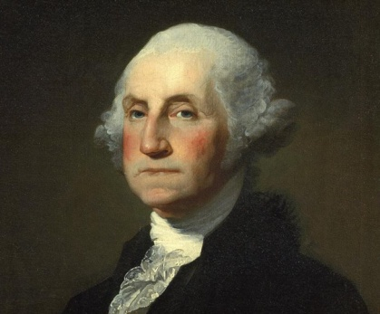

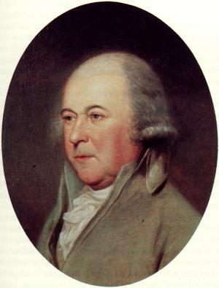

2. John Adams
John Adams was an important figure in both the First and Second Continental Congresses. He was on the committee to draft the Declaration of Independence and was central to its adoption. He was chosen to help negotiate the Treaty of Paris that officially ended the American Revolution. He later became the first vice president and then the second president of the United States.
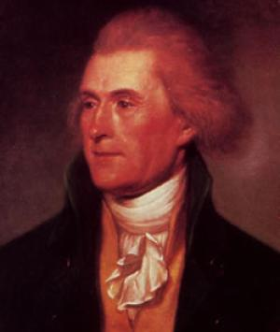

3. Thomas Jefferson
Thomas Jefferson, as a delegate to the Second Continental Congress, was chosen to be part of a Committee of Five that would draft the Declaration of Independence. He was unanimously picked to write the Declaration. He was then sent to France as a diplomat after the Revolution and then returned to become first the vice president under John Adams and then the third president.
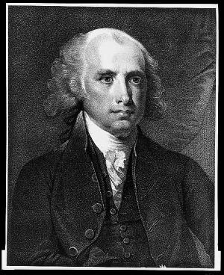

4. James Madison
James Madison was known as the Father of the Constitution, for he was responsible for writing much of it. Further, with John Jay and Alexander Hamilton, he was one of the authors of the Federalist Papers that helped persuade the states to accept the new Constitution. He was responsible for drafting the Bill of Rights that were added to the Constitution in 1791. He helped organize the new government and later became the fourth president of the United States.

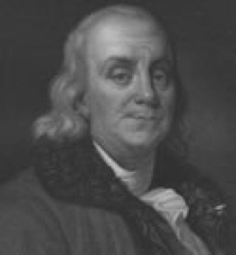

5. Benjamin Franklin
Benjamin Franklin was considered the elder statesman by the time of the Revolution and later Constitutional Convention. He was a delegate to the Second Continental Congress. He was part of the Committee of Five that was to draft the Declaration of Independence and made corrections that Jefferson included in his final draft. Franklin was central to getting French aid during the American Revolution. He also helped with negotiating the Treaty of Paris that ended the war.
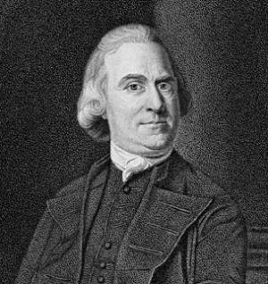

6. Samuel Adams
Samuel Adams was a true revolutionary. He was one of the founders of the Sons of Liberty. His leadership helped organize the Boston Tea Party. He was a delegate to both the First and Second Continental Congresses and fought for the Declaration of Independence. He also helped draft the Articles of Confederation. He helped write the Massachusetts Constitution and became its governor.
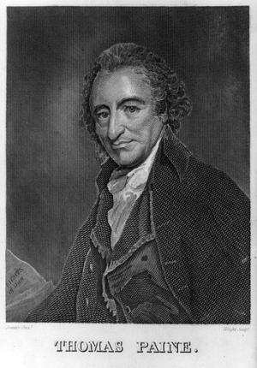

7. Thomas Paine
Thomas Paine was the author of a very important pamphlet called Common Sense that was published in 1776. He wrote a compelling argument for independence from Great Britain. His pamphlet convinced many colonists and founding fathers of the wisdom of open rebellion against the British if necessary. Further, he published another pamphlet called The Crisis during the Revolutionary War that helped spur on the soldiers to fight.
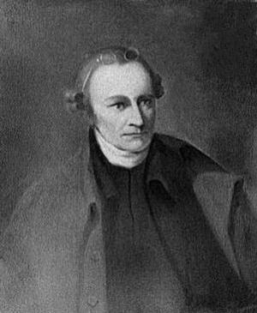

8. Patrick Henry
Patrick Henry was a radical revolutionary who was unafraid to speak up against Great Britain at an early date. He is most famous for his speech which includes the line, "Give me liberty or give me death." He was a governor of Virginia during the Revolution. He also helped fight for the addition of the Bill of Rights to the US Constitution, a document with which he disagreed because of its strong federal powers.
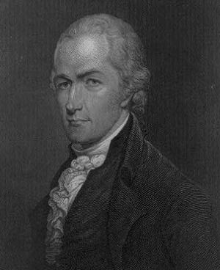

9. Alexander Hamilton
Hamilton fought in the Revolutionary War. However, his true importance came about after the war when he was a huge proponent for the US Constitution. He, along with John Jay and James Madison, wrote the Federalist Papers in an effort to secure support for the document. Once Washington was elected as the first president, Hamilton was made the first Secretary of the Treasury. His plan for getting the new country on its feet economically was instrumental in forming a sound financial basis for the new republic.

