The Three Branches of Government
Delegates at the Constitutional Convention also wanted to divide power within the federal government. They did not want these powers to be controlled by just one man or one group. The delegates were afraid that if a small group received too much power, the United States would wind up under the rule of another dictator or tyrant.
To avoid the risk of dictatorship or tyranny, the group divided the new government into three parts, or branches: the executive branch, the legislative branch, and the judicial branch.
Executive Branch: Headed by the president. The president carries out federal laws and recommends new ones, directs national defense and foreign policy, and performs ceremonial duties. Powers include directing government, commanding the Armed Forces, dealing with international powers, acting as chief law enforcement officer, and vetoing laws.
Legislative Branch: Headed by Congress, which includes the House of Representatives and the Senate. The main task of these two bodies is to make the laws. Its powers include passing laws, originating spending bills (House), impeaching officials (Senate), and approving treaties (Senate).
Judicial Branch: Headed by the Supreme Court. Its powers include interpreting the Constitution, reviewing laws, and deciding cases involving states' rights.
By creating three branches of government, the delegates built a "check and balance" system into the Constitution. This system was built so that no one branch of our government could become too powerful.
Each branch is restrained by the other two in several ways. For example, the president may veto a law passed by Congress. Congress can override that veto with a vote of two-thirds of both houses. Another example is that the Supreme Court may check Congress by declaring a law unconstitutional. The power is balanced by the fact that members of the Supreme Court are appointed by the president. Those appointments have to be approved by Congress.

Three Branches of Government
In 1787 leaders of the states gathered to write the Constitution-a set of principles that told how the new nation would be governed. The leaders of the states wanted a strong and fair national government. But they also wanted to protect individual freedoms and prevent the government from abusing its power. They believed they could do this by having three separate branches of government: the executive, the legislative and the judicial. This separation is described in the first three articles, or sections, of the Constitution.

Legislative Branch
The legislative branch is made up of the two houses of Congress—the Senate and the House of Representatives. The most important duty of the legislative branch is to make laws. Laws are written, discussed and voted on in Congress.
There are 100 senators in the Senate, two from each state. Senators are elected by their states and serve six-year terms. The Vice President of the U.S. is considered the head of the Senate, but does not vote in the Senate unless there is a tie. The Senate approves nominations made by the President to the Cabinet, the Supreme Court, federal courts and other posts. The Senate must ratify all treaties by a two-thirds vote.
There are 435 representatives in the House of Representatives. The number of representatives each state gets is based on its population. For example, California has many more representatives than Rhode Island. When Census figures determine that the population of a state has changed significantly, the number of representatives in that state may shift proportionately. Representatives are elected by their states and serve two-year terms. The Speaker of the House, elected by the representatives, is considered the head of the House.
Both parties in the Senate and the House of Representatives elect leaders. The leader of the party that controls the house is called the majority leader. The other party leader is called the minority leader.

Executive Branch
The President is the head of the executive branch, which makes laws official. The President is elected by the entire country and serves a four-year term. The President approves and carries out laws passed by the legislative branch. He appoints or removes cabinet members and officials. He negotiates treaties, and acts as head of state and commander in chief of the armed forces.
The executive branch also includes the Vice President and other officials, such as members of the cabinet. The cabinet is made up of the heads of the 15 major departments of the government. The cabinet gives advice to the President about important matters.
The Cabinet
- The Secretary of State
- The Secretary of the Treasury
- The Secretary of Defense
- The Attorney General (Justice Department)
- The Secretary of the Interior
- The Secretary of Agriculture
- The Secretary of Commerce
- The Secretary of Labor
- The Secretary of Health and Human Services
- The Secretary of Homeland Security
- The Secretary of Housing and Urban Development
- The Secretary of Transportation
- The Secretary of Education
- The Secretary of Energy
- The Secretary of Veterans' Affairs

Judicial Branch
The judicial branch oversees the court system of the U.S. Through court cases, the judicial branch explains the meaning of the Constitution and laws passed by Congress. The Supreme Court is the head of the judicial branch. Unlike a criminal court, the Supreme Court rules whether something is constitutional or unconstitutional—whether or not it is permitted under the Constitution.
On the Supreme Court there are nine justices, or judges: eight associate justices and one chief justice. The judges are nominated by the President and approved by the Senate. They have no term limits. The Supreme Court is the highest court in the land. Its decisions are final, and no other court can overrule those decisions. Decisions of the Supreme Court set precedents—new ways of interpreting the law.

The Bill of Rights
Amendment I
Congress shall make no law respecting an establishment of religion, or prohibiting the free exercise thereof; or abridging the freedom of speech, or of the press; or the right of the people peaceably to assemble, and to petition the government for a redress of grievances.

Amendment II
A well regulated militia, being necessary to the security of a free state, the right of the people to keep and bear arms, shall not be infringed.

Amendment III
No soldier shall, in time of peace be quartered in any house, without the consent of the owner, nor in time of war, but in a manner to be prescribed by law.
Amendment IV
The right of the people to be secure in their persons, houses, papers, and effects, against unreasonable searches and seizures, shall not be violated, and no warrants shall issue, but upon probable cause, supported by oath or affirmation, and particularly describing the place to be searched, and the persons or things to be seized.

Amendment V
No person shall be held to answer for a capital, or otherwise infamous crime, unless on a presentment or indictment of a grand jury, except in cases arising in the land or naval forces, or in the militia, when in actual service in time of war or public danger; nor shall any person be subject for the same offense to be twice put in jeopardy of life or limb; nor shall be compelled in any criminal case to be a witness against himself, nor be deprived of life, liberty, or property, without due process of law; nor shall private property be taken for public use, without just compensation.

Amendment VI
In all criminal prosecutions, the accused shall enjoy the right to a speedy and public trial, by an impartial jury of the state and district wherein the crime shall have been committed, which district shall have been previously ascertained by law, and to be informed of the nature and cause of the accusation; to be confronted with the witnesses against him; to have compulsory process for obtaining witnesses in his favor, and to have the assistance of counsel for his defense.

Amendment VII
In suits at common law, where the value in controversy shall exceed twenty dollars, the right of trial by jury shall be preserved, and no fact tried by a jury, shall be otherwise reexamined in any court of the United States, than according to the rules of the common law.

Amendment VIII
Excessive bail shall not be required, nor excessive fines imposed, nor cruel and unusual punishments inflicted.

Amendment IX
The enumeration in the Constitution, of certain rights, shall not be construed to deny or disparage others retained by the people.

Amendment X
The powers not delegated to the United States by the Constitution, nor prohibited by it to the states, are reserved to the states respectively, or to the people.

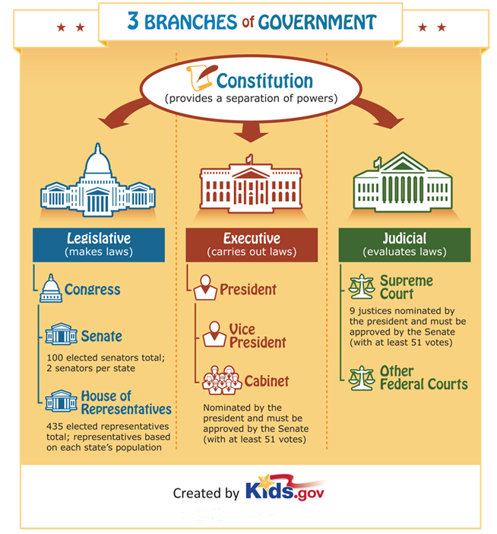

Constitution
The Founding Fathers, the framers of the Constitution, wanted to form a government that did not allow one person to have too much control. With this in mind, the framers wrote the Constitution to provide for a separation of powers, or three separate branches of government. Each has its own responsibilities and at the same time they work together to make the country run smoothly and to assure that the rights of citizens are not ignored or disallowed. This is done through checks and balances. A branch may use its powers to check the powers of the other two in order to maintain a balance of power among the three branches of government.

Legislative - Makes Laws
Congress is composed of two parts: the Senate and the House of Representatives.
Senate
The Senate has 100 elected senators total; 2 senators per state. Each senator serves a 6 year term.
House of Representatives
The House has 435 voting representatives; the number of representatives from each state is based on the state's population. Each representative serves a 2 year term and may be re-elected.

Executive - Carries Out Laws
The executive branch is composed of the President, Vice President and Cabinet members.
President
The president is the head of state, head of the U.S. government and the commander-in-chief of the U.S. military.
Vice President
The vice president not only supports the president, but also acts as the presiding officer of the senate.
Cabinet
The Cabinet members are nominated by the president and must be approved by the Senate (with at least 51 votes). They serve as advisors and heads of various departments and agencies.

Judicial - Evaluates Laws
The judicial branch of government is made up of the court system.
Supreme Court
The Supreme Court is the highest court in the country. The 9 justices are nominated by the president and must be approved by the Senate (with at least 51 votes).
Other Federal Courts
There are lower Federal courts but they were not created by the Constitution. Congress deemed them necessary and established them using power granted from the Constitution.

How a Bill Becomes a Law
Creating laws is the U.S. House of Representatives’ most important job. All laws in the United States begin as bills. Before a bill can become a law, it must be approved by the U.S. House of Representatives, the U.S. Senate, and the President. Let’s follow a bill’s journey to become law.

The Bill Begins
Laws begin as ideas. These ideas may come from a Representative—or from a citizen like you. Citizens who have ideas for laws can contact their Representatives to discuss their ideas. If the Representatives agree, they research the ideas and write them into bills.

The Bill Is Proposed
When a Representative has written a bill, the bill needs a sponsor. The Representative talks with other Representatives about the bill in hopes of getting their support for it. Once a bill has a sponsor and the support of some of the Representatives, it is ready to be introduced.

The Bill Is Introduced
In the U.S. House of Representatives, a bill is introduced when it is placed in the hopper—a special box on the side of the clerk’s desk. Only Representatives can introduce bills in the U.S. House of Representatives.
When a bill is introduced in the U.S. House of Representatives, a bill clerk assigns it a number that begins with H.R. A reading clerk then reads the bill to all the Representatives, and the Speaker of the House sends the bill to one of the House standing committees.

The Bill Goes to Committee
When the bill reaches committee, the committee members—groups of Representatives who are experts on topics such as agriculture, education, or international relations—review, research, and revise the bill before voting on whether or not to send the bill back to the House floor.
If the committee members would like more information before deciding if the bill should be sent to the House floor, the bill is sent to a subcommittee. While in subcommittee, the bill is closely examined and expert opinions are gathered before it is sent back to the committee for approval.

The Bill Is Reported
When the committee has approved a bill, it is sent—or reported—to the House floor. Once reported, a bill is ready to be debated by the U.S. House of Representatives.

The Bill Is Debated
When a bill is debated, Representatives discuss the bill and explain why they agree or disagree with it. Then, a reading clerk reads the bill section by section and the Representatives recommend changes. When all changes have been made, the bill is ready to be voted on.

The Bill Is Voted On
If a majority of the Representatives say or select yes, the bill passes in the U.S. House of Representatives. The bill is then certified by the Clerk of the House and delivered to the U.S. Senate.

The Bill Is Referred to the Senate
When a bill reaches the U.S. Senate, it goes through many of the same steps it went through in the U.S. House of Representatives. The bill is discussed in a Senate committee and then reported to the Senate floor to be voted on.
Senators vote by voice. Those who support the bill say “yea,” and those who oppose it say “nay.” If a majority of the Senators say “yea,” the bill passes in the U.S. Senate and is ready to go to the President.

The Bill Is Sent to the President
When a bill reaches the President, he has three choices. He can:
- Sign and pass the bill—the bill becomes a law.
- Refuse to sign, or veto, the bill—the bill is sent back to the U.S. House of Representatives, along with the President’s reasons for the veto. If the U.S. House of Representatives and the U.S. Senate still believe the bill should become a law, they can hold another vote on the bill. If two-thirds of the Representatives and Senators support the bill, the President’s veto is overridden and the bill becomes a law.
- Do nothing (pocket veto)—if Congress is in session, the bill automatically becomes law after 10 days. If Congress is not in session, the bill does not become a law.

The Bill Is a Law
If a bill has passed in both the U.S. House of Representatives and the U.S. Senate and has been approved by the President, or if a presidential veto has been overridden, the bill becomes a law and is enforced by the government.

